Unit 3: National Income and Price Determination

Aggregate Demand

Topic 1: Determinants of aggregate demand

Difficulty Level 2
- All other things unchanged, an increase in the price level causes
  - a rightward shift of the aggregate demand curve.
  - an increase in the purchasing power of assets.
  - an upward movement along the aggregate demand curve.
  - a downward movement along the aggregate demand curve.
  - a leftward shift of the aggregate demand curve.
- Inflation causes the price level to rise in the United States. How does this inflation affect households?
  - The purchasing power of wealth increases and consumer spending increases.
  - The purchasing power of wealth decreases and consumer spending decreases.
  - The purchasing power of wealth remains constant and consumer spending remains constant.
  - The purchasing power of wealth decreases and consumer spending increases.
  - The purchasing power of wealth increases and consumer spending decreases.
- How will a decrease in price level affect the interest rate and interest-sensitive spending?
Interest Rate Interest-sensitive spending
  - Increases Increases
  - Decreases Decreases
  - Increases Decreases
  - Decreases Increases
  - Decreases Remains the same
- Aggregate demand is measured by adding together which of the following?
  - domestic spending and imports
  - domestic private consumption and government spending
  - consumption, investment, government spending, and net exports
  - savings, business inventories, profits, and net exports
  - consumption, investment, government spending, and imports
- Which of the following examples demonstrates a condition in which consumption spending would most likely increase?
  - Consumers believe their wages will be cut next year
  - The government encourages consumers to save for retirement
  - Congress passes an increase in payroll taxes
  - The price level increases
  - Changes in the stock market increases consumers’ wealth
Use the graph below to answer the following question.
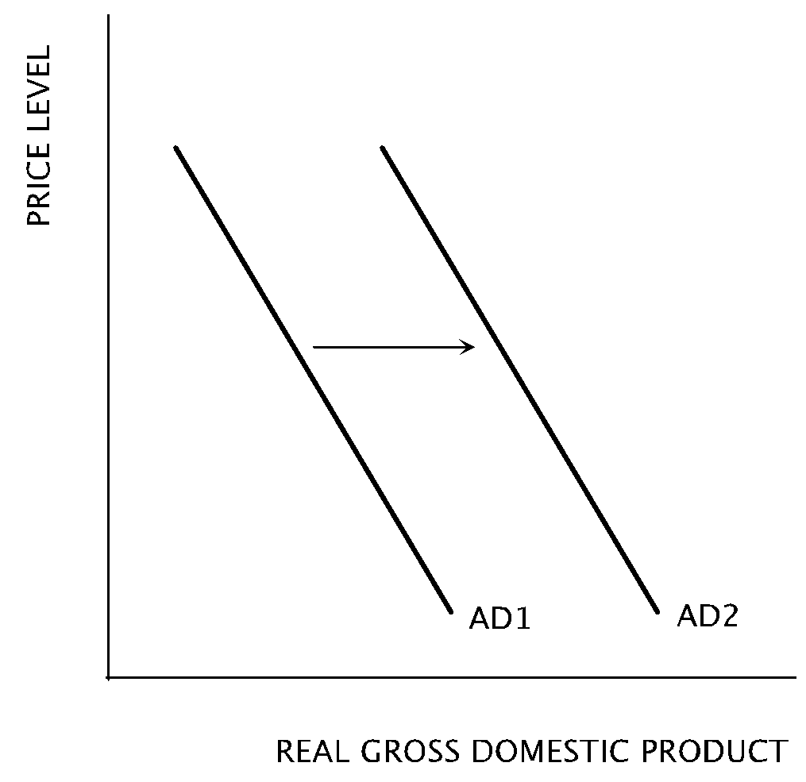
- Which of the following changes would cause an economy’s aggregate demand curve to shift from AD1 to AD2?
  - An increase in interest rates
  - An increase in consumer optimism
  - An increase in spending on imports
  - A decrease in the money supply
  - A decrease in the price level in the economy
Use the graph below to answer the following questions.
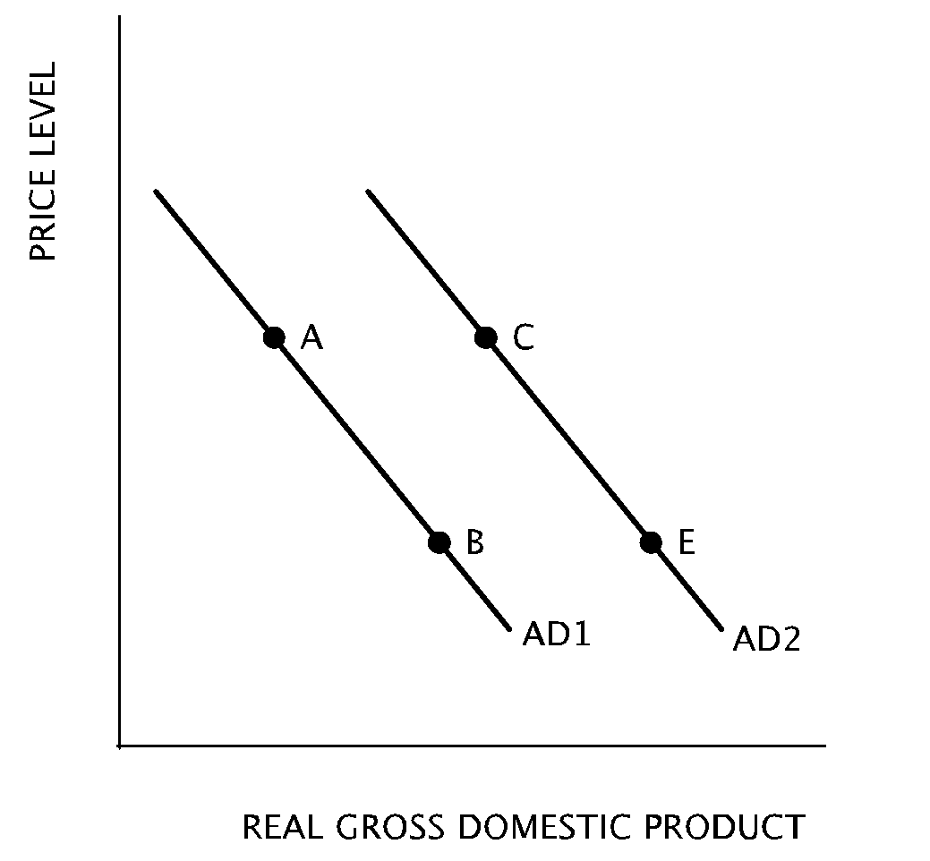
- A movement from Point A on AD1 to Point C on AD2 can be caused by which of the following changes?
  - A decrease in overall price level
  - A decrease in wealth
  - An increase in interest rates
  - An increase in overall price level
  - An increase in government purchases
- Price level is falling and consumers’ wealth and assets increase in purchasing power. Which movement on the graph best represents this change?
  - From Point E to Point C
  - From Point E to Point B
  - From Point C to Point B
  - From Point A to Point C
  - From Point A to Point B

Difficulty Level 3
- A decrease in which of the following would cause the aggregate demand curve to shift to the right?
  - Population
  - Value of the stock market
  - Labor productivity
  - Imports
  - Consumer optimism
- When the government runs a budget deficit, it increases its demand of loanable funds, crowding out private investment spending. Which movement on the graph represents the resulting increase in interest rates?
  - From Point E to Point C
  - From Point E to Point B
  - From Point C to Point B
  - From Point A to Point C
  - From Point A to Point B

Topic 2: Multiplier and crowding-out effects

Difficulty Level 2
- If the marginal propensity to save is 0.9, then the marginal propensity to consume is
Aggregate Demand
1 | C | 6 | B | 11 | A | 16 | D
2 | B | 7 | E | 12 | C | 17 | D
3 | D | 8 | E | 13 | A | 18 | D
4 | C | 9 | D | 14 | A | 19 | E
5 | E | 10 | B | 15 | C | 20 | E

  - 0.1
  - 0.3
  - 0.9
  - 1.0
  - 10.0
- If the marginal propensity to consume equals 0.8, then the multiplier is
  - 2
  - 3
  - 5
  - 8
  - 10
- If the marginal propensity to consume increases, which of the following is necessarily true?
  - The marginal propensity to save decreases
  - The marginal tax rate increases
  - The economy is nearing full employment
  - Consumption is unaffected when income changes
  - The unemployment rate increases
- The value of the spending multiplier increases when
  - the marginal propensity to save decreases
  - government spending decreases
  - tax rates are increased
  - imports increase
  - exports decrease
- Terry’s marginal propensity to consume is 0.8. Last year he earned $50,000 in disposable income and spent $45,000. If Terry’s disposable income this year increased to $60,000, his consumption spending increased by
  - $4,000
  - $5,000
  - $8.000
  - $9.000
  - $10,000
- Suppose that the marginal propensity to consume is equal to 0.8 in a closed economy with only lump-sum taxes. What is the maximum increase in output that can be caused by a $50 billion increase in government spending?
  - $40 billion
  - $50 billion
  - $100 billion
  - $250 billion
  - $400 billion
- Which of the following statements about the marginal propensity to consume is true?
  - It is always equal to the money multiplier.
  - It is equal to the percentage of total income that is spent on consumption.
  - It increases as individuals increase their savings.
  - It determines the size of the spending multiplier.
  - It is always equal to the marginal propensity to save.

Difficulty Level 3
- Suppose that autonomous consumption is $500 and that the marginal propensity to consume is 0.75. If disposable income increases by $1100, consumption spending will increase by
  - $275
  - $375
  - $495
  - $825
  - $1100
- Which of the following changes will have the smallest expansionary effect on aggregate demand in the short run?
  - An increase in consumption of $200
  - An increase in government spending of $200
  - An increase in exports of $200
  - A decrease in savings of $200
  - A decrease in taxes of $200
- Assume an economy with lump-sum taxes and no international trade. If the marginal propensity to consume is 0.75, which of the following is true?
  - When income increases by $1, investment increases by a maximum of $4.
  - When consumption increases by $4, savings increase by a maximum of $1.
  - When consumption increases by $4, investment increases by a maximum of $1.
  - When investment increases by $1, consumption increases by a maximum of $4.
  - When investment increases by $1, income increases by a maximum of $4.

Aggregate Supply

Topic 1: Short-run and long-run analyses

Difficulty Level 1
- The aggregate supply curve shows the relationship between the aggregate output supplied and
  - aggregate price level
  - aggregate money supply
  - aggregate unemployment rate
  - aggregate imports
  - aggregate real interest rate
- According to the short-run aggregate supply curve, as price level rises in the economy
  - worker productivity rises
  - the unemployment rate decreases
  - aggregate supply increases
  - the quantity of aggregate supply increases
  - the quantity of aggregate supply decreases

Difficulty Level 2
- Which of the following statements is true about the “short-run” period in macroeconomic analysis?
  - It is equal to one fiscal year
  - It is equal to the time needed to end a recession
  - It is a period in which wages and input prices are fully flexible
  - It is a period in which wages and input prices are fixed
  - It is a period in which price level does not change

- In the long-run, the price of labor is flexible. What is the resulting effect on the aggregate supply curve?
  - It becomes horizontal
  - It becomes vertical
  - It becomes negatively sloped
  - It becomes positively sloped
  - It does not change
- Since wages and input prices are fixed, or “sticky,” in the short-run, how will producers likely respond to a increase in price level in the economy?
  - Producers will increase production of goods and services
  - Producers will decrease production of goods and services
  - Producers will not change the quantity of goods and services produced
  - Producers will lay off workers
  - Producers will reduce purchases of physical capital

Difficulty Level 3
- What is the effect of an increase in price level on the quanity of aggregate output supplied in the short-run and in the long-run?
Short-run output Long-run output
  - Increase Increase
  - Increase Remains the same
  - Decrease Remains the same
  - Increase Decrease
  - Remains the same Remains the same

Topic 2: Sticky versus flexible wages and prices

Difficulty Level 1
- Employers are reluctant to increase nominal wages during an economic expansion and workers are reluctant to accept wage cuts to nominal wages during an economic downturn. Which term best describes wages in this labor market?
  - Flexible
  - Real
Aggregate Supply
1 | A | 6 | B | 11 | A
2 | D | 7 | D | 12 | D
3 | D | 8 | B | 13 | E
4 | B | 9 | D | 14 | C
5 | A | 10 | C | 15 | C

  - Potential
  - Sticky
  - Variable

Difficulty Level 2
- Which of the following choices best describes wages in the short-run and in the long-run?
Short-run Long-run
  - Fixed Fixed
  - Fixed Flexible
  - Flexible Flexible
  - High Low
  - Low High

Topic 3: Determinants of aggregate supply

Difficulty Level 2
- Which of the following changes will cause an increase in short-run aggregate supply?
  - an increase in nominal wages
  - an decrease in personal income taxes
  - a decrease in labor productivity
  - a decrease in commodity prices
  - an increase in the aggregate money supply
- An increase in nominal wages will most likely result in
  - an increase in aggregage demand.
  - a decrease in aggregate demand.
  - a decrease in short-run aggregate supply.
  - an increase in short-run aggregate supply.
  - a decrease in long-run aggregate supply.
Use the graph below to answer the following questions.
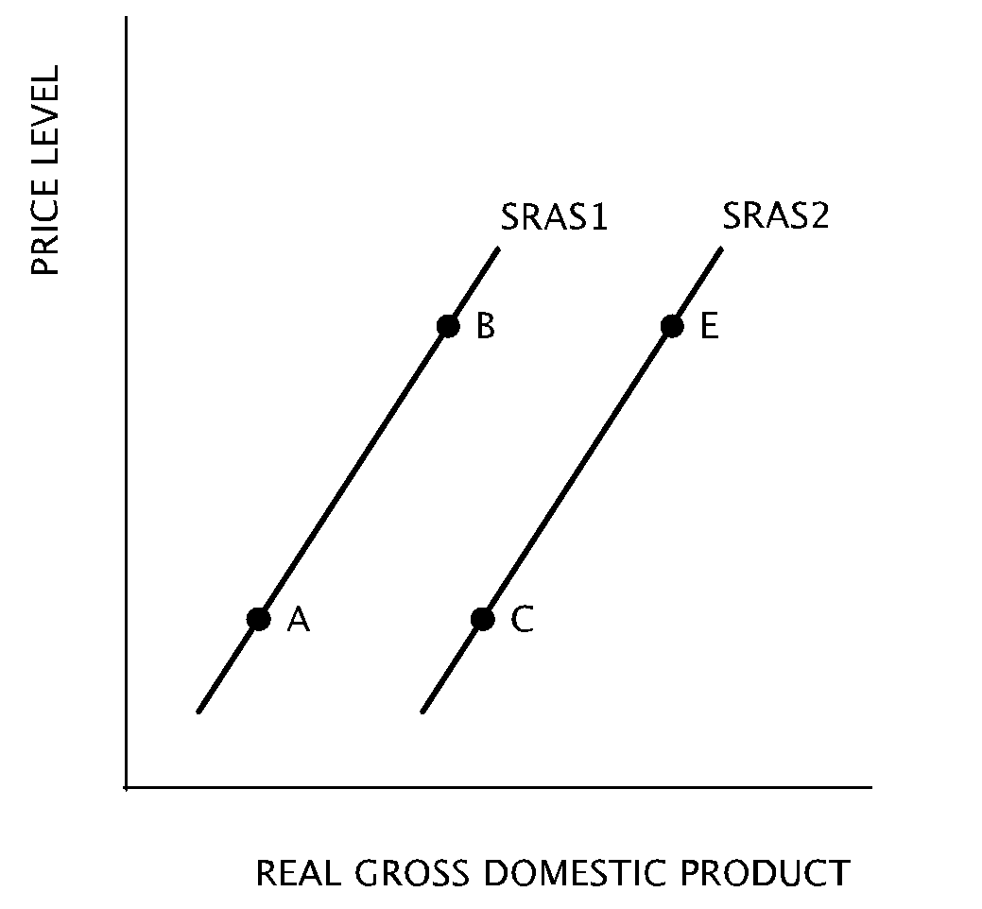
- A movement from Point A on SRAS1 to Point C on SRAS2 is likely to occur when there is an increase in
  - the cost of productive resources
  - productivity
  - price level
  - the federal budget deficit
  - the money supply
- A tax increase of 75 cents per gallon of gasoline would likely cause a movement
  - from Point A to Point B
  - from Point B to Point A
  - from Point B to Point E
  - from Point E to Point B
  - from Point C to Point B
- Which movement on the graph would best represent an economy in which a new law is passed mandating a reduction in automobile pollution?
  - from Point A to Point B
  - from Point B to Point A
  - from Point B to Point E
  - from Point C to Point B
  - from Point C to Point A
- Which of the following changes will likely cause a movement from Point B on SRAS1 to Point E on SRAS2?
  - The shutdown of factories and movement of production of goods abroad
  - A decrease in the money supply
  - An across-the-board reduction in wages in manufacturing jobs
  - An increase in the effective minimum wage
  - The passage of a new law requiring improvements in worker safety
- A movement from Point A on SRAS1 to Point B on SRAS2 is likely to occur when there is an increase in
  - the cost of productive resources
  - productivity
  - price level
  - imports
  - interest rates

Macroeconomic Equilibrium

Topic 1: Real output and price level

Difficulty Level 2
- An increase in government spending will most likely cause the price level and real gross domestic product to change in which of the following ways?
Price Level Real Gross Domestic Product
  - Increase Increase
  - Increase Decrease
  - Increase Not change
  - Decrease Increase
  - Decrease Decrease
- If businesses grow more optimistic and increase their purchases of physical capital, how will the price level and real gross domestic product likely change?
Price Level Real Gross Domestic Product
  - Increase Increase
  - Increase Decrease
  - Increase Not change
  - Decrease Increase
  - Decrease Not change
- An increase in personal income taxes will most likely cause the price level and real gross domestic product to change in which of the following ways?
Price Level Real Gross Domestic Product
  - Increase Increase
  - Decrease Decrease
  - Increase Decrease
  - Decrease Increase
  - Decrease Not change
Use the graph below to answer the following question.
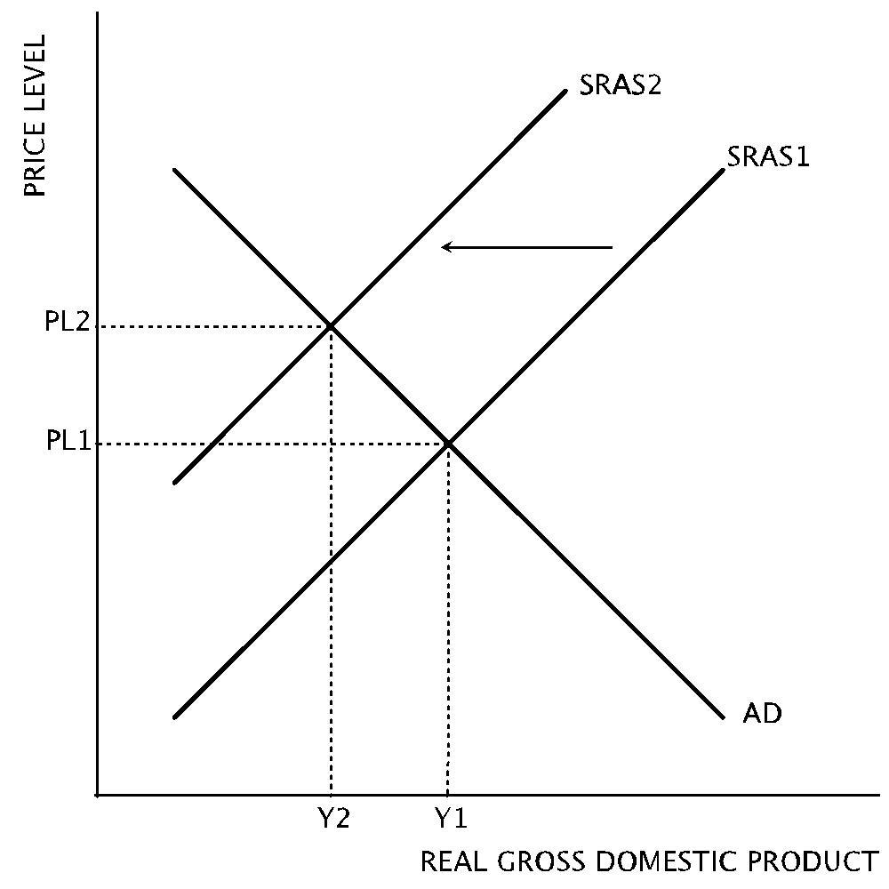
- Which of the following likely caused the change represented in the graph?
  - an increase in the money supply
  - an increase in the price of imported oil
  - a decrease in the price of imported oil
  - an increase in personal income taxes
  - a decrease in nominal interest rates
- If an increase in aggregate supply is followed by a decrease in aggregage demand, which of the following will necessarily occur?
  - The price level will increase.
  - The price level will decrease.
  - Output will increase.
  - Output will not change.
  - Output will decrease.
- Stagflation may result from which of the following changes?
  - A positive demand shock
  - A negative demand shock
  - A positive supply shock
  - A negative supply shock
  - A positive supply shock and a negative demand shock
- An increase in net exports will likely result in
  - increasing aggregate output and a decrease in price level
  - a decrease in the unemployment rate
  - no change in aggregate output and price level
  - a decrease in short-run aggregate supply
  - an increase in the price level and unemployment rate

Difficulty Level 3
- Suppose the aggregate price level is increasing and the equilibrium level of aggregate output is decreasing. An increase in which of the following most likely caused these changes?
  - Industrial production
  - Government defense spending
  - Nominal wages
  - The corporate tax rate
  - Worker productivity
- An unanticipated decrease in aggregate output and price level when the economy is in equilibrium will result in
  - an increase in unplanned inventories
  - an increase in nominal interest rates
  - a decrease in unemployment
  - a decrease in the money supply
  - a decrease in aggregate supply
Use the graph below to answer the following question.
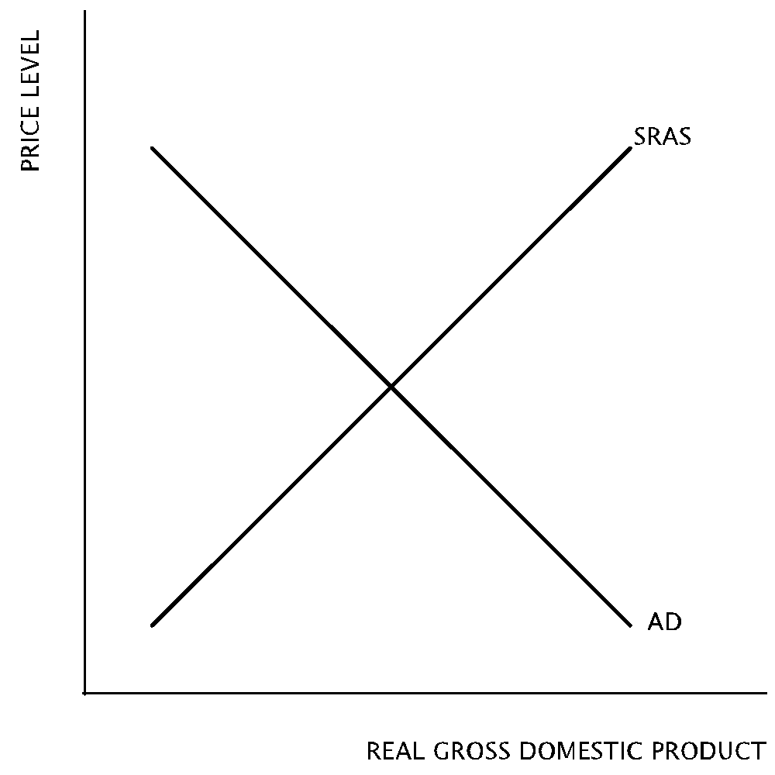
- According to the graph, which of the following will necessarily result in an increase in output?
- A rightward shift of the aggregated demand curve
- A rightward shift of the short-run aggregate supply curve
- A leftward shift of the aggregate demand curve
- A leftward shift of the short-run aggregate supply curve
  - I only
  - II only
  - I and II only
  - II and III only
  - I and IV only

Topic 2: Short and long run

Difficulty Level 2
Use the graph below to answer the following question.
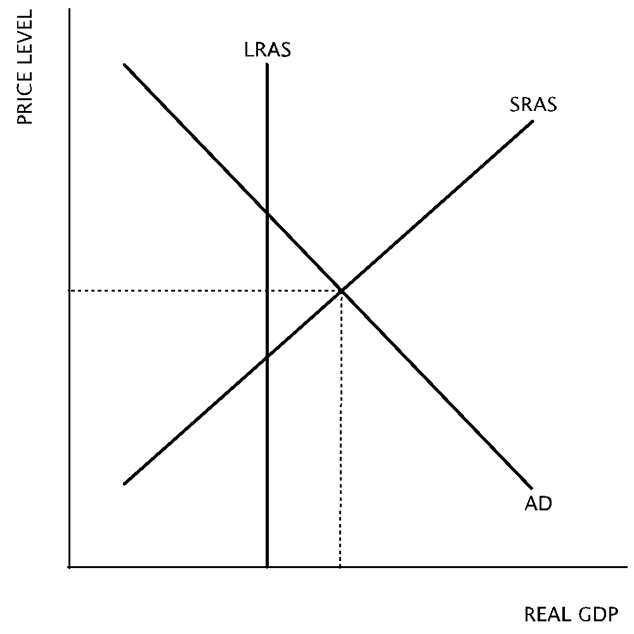
- According to the graph, which of the following statements about the long-run equilibrium of the economy depicted is true?
  - The economy will remain in a recession without an expansionary monetary policy.
  - The short-run aggregate supply curve will shift to the left to restore long-run equilibrium when nominal wages increase.
  - The economy is in long-run equilibrium.
  - The unemployment rate will decrease as the economy is restored to long-run equilibrium.
  - The aggregate demand curve will shift to the left to restore long-run equilibrium.

Difficulty Level 3
Use the graph below to answer the following question.
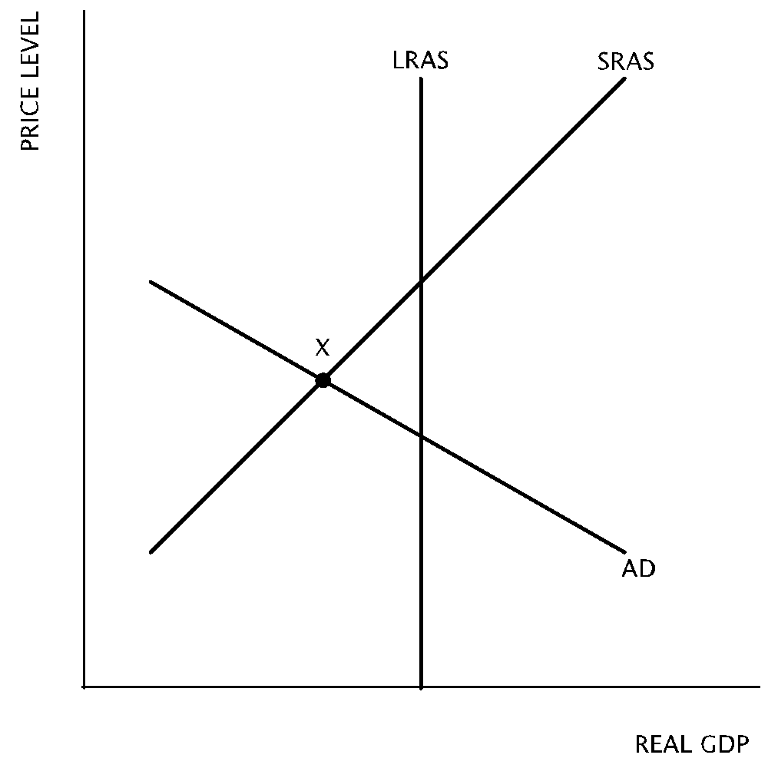
- If no fiscal or monetary policy is used to address the state of this economy, how will it change in the long-run?
  - As nominal wages increase aggregate demand will shift to right to restore long-run equilibrium
  - As nominal wages increase short-run aggregate supply will shift to the right to restore long-run equilibrium
  - As nominal wages decrease short-run aggregate supply will shift to the right to restore long-run equilibrium
  - As nominal wages decrease long-run aggregate supply will shift to the left to restore long-run equilibrium
  - No changes will occur
- If an economy is currently producing at the full-employment level of output, what will be the effect on the unemployment rate of an increase in the value of the stock market in the short-run and in the long-run?
Short-run Long-run
  - Increase No change
  - Increase Increase
  - Decrease Decrease
  - Decrease No change
  - Increase Decrease
Use the graph below to answer the following question.
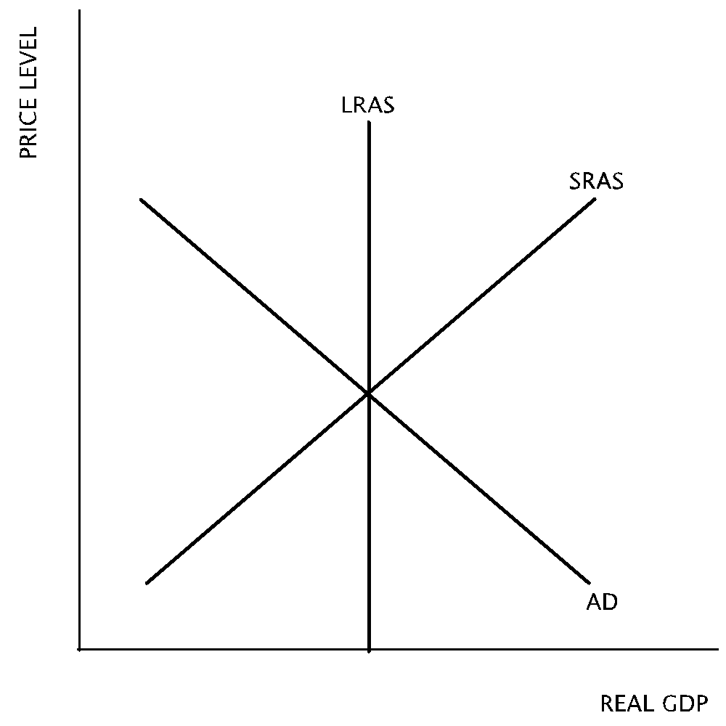
- In the economy depicted in the graph, what will result in the long-run if the government doubles its spending on health care.
Output Price level
  - Increase No change
  - No change Increase
  - Decrease No change
  - No change Decrease
  - No change No change

Topic 3: Actual v. full employment output

Difficulty Level 2
- When an economy is in recession, the actual unemployment rate is
  - equal to the unemployment rate at full employment output
  - less than the natural rate of unemployment
  - more than the natural rate of unemployment
  - equal to the natural rate of unemployment
  - more than 8 percent
Use the graph below to answer the following question.
- According to the graph, which of the following statements about the unemployment rate is true?
  - Cyclical, frictional, and structural unemployment exist.
  - The unemployment rate is above the natural rate of unemployment.
  - The economy is producing above full employment output.
  - The unemployment rate is equal to the cyclical rate.
  - The economy is producing at full employment output.

Topic 4: Business cycle and economic fluctuations

Difficulty Level 2
Use the following graph to answer the question below.
- According to the graph, if the economy is at point X, there is
  - long-run equilibrium with full employment.
  - a recessionary gap with high unemployment.
  - an inflationary gap with low unemployment.
  - an inflationary gap with high unemployment.
  - a recessionary gap with low unemployment.
- Which of the following statements is true about a recessionary gap?
  - The unemployment rate is below the natural rate of unemployment
  - Aggregate output is below potential output
  - Potential output is below aggregate output
  - Aggregate output is above potential output
  - The economy is experiencing full employment
- Assuming the economy is in long-run equilibrium, which of the following changes will create an inflationary gap?
- An increase in the wealth of households.
- An decrease in the supply of imported oil.
- An increase in government spending.
  - I only
  - II only
  - III only
  - I and III only
  - II and III only

Macroeconomic Equilibrium
1 | A | 6 | D | 11 | B | 16 | E
2 | A | 7 | B | 12 | C | 17 | B
3 | B | 8 | C | 13 | D | 18 | B
4 | B | 9 | A | 14 | B | 19 | D
5 | B | 10 | C | 15 | C

Aggregate Demand
1 | C | 6 | B | 11 | A | 16 | D
2 | B | 7 | E | 12 | C | 17 | D
3 | D | 8 | E | 13 | A | 18 | D
4 | C | 9 | D | 14 | A | 19 | E
5 | E | 10 | B | 15 | C | 20 | E

Aggregate Supply
1 | A | 6 | B | 11 | A
2 | D | 7 | D | 12 | D
3 | D | 8 | B | 13 | E
4 | B | 9 | D | 14 | C
5 | A | 10 | C | 15 | C

Answers Unit 3: National Income and Price Determination

Aggregate Demand

Topic 1: Determinants of aggregate demand

Difficulty Level 2
- Correct answer: C
There is an inverse relationship between price level and quantity of aggregate output demanded. As price level rises, the purchasing power of wealth like assets and savings falls. Also, interest rates rise so interest-sensitive spending falls. Finally, at higher prices, domestic exports decrease. Overall, the quantity of domestic output demanded decreases, which is represented by a movement upward and along the aggregate demand curve.
Incorrect Answer
The answer choices reference the aggregate demand curve, which shows the relationship between price level and aggregate output demanded. The aggregate demand curve shows an inverse relationship between price level and quantity of aggregate output demanded. Try drawing the graph for help.
- Correct answer: B
As price level rises, the purchasing power of wealth (assets and savings) falls. Since this wealth now has less purchasing power, consumer spending decreases.
Incorrect Answer
Wealth include a household’s assets and savings. What happens to the purchasing power of wealth as prices rise?
- Correct answer: D
Banks respond to a decrease in price level by decreasing interest rates. Interest-sensitive spending, such as auto, home, and physical capital purchases increase in response.
Incorrect Answer
Among the prices that tend to decrease when price level falls is the price of a loan—the interest rate. How does a decrease in the interest rate affect interest-sensitive spending?
- Correct answer: C
To measure aggregate demand, add together all of the spending on domestic production: consumption spending, investment spending, government spending, and exports, and then subtract spending on imports.
Incorrect Answer
To measure aggregate demand, add together all spending on domestic production and subtract domestic spending on foreign production.
- Correct answer: E
If changes in the stock market cause consumers’ wealth to increase, consumers feel richer and tend to consume more.
Incorrect Answer
Which change would make consumers feel richer?
- Correct answer: B
The graph shows a rightward shift of the aggregate demand curve, which indicates that aggregate demand is increasing at all price levels. The only choice that causes an increase in aggregate demand is an increase in consumer optimism.
Be careful not to select E, which would cause an increase in the quantity of aggregate output demanded. Such an increase would be represented by a movement downward along the AD1 curve.
- Correct answer: E
The movement from Point A to Point C represents an increase in aggregate demand, which can be caused by an increase in government expenditures. The other choices represent movements along the curve (caused by a change in price level) or a decrease in aggregate demand.
Incorrect Answer
The movement from Point A to Point C represents an increase in aggregate demand, which cannot be caused by a price change. Eliminate those answer choices.
- Correct answer: E
The only choice that demonstrates a decrease in price level is a movement from Point A to Point B, which is a movement down along the curve. As the price falls, the value of consumers’ wealth grows and they increase the quantity of aggregate output demanded.
Incorrect Answer
When price level changes, there is a movement along the AD curve. When a factor other than price level changes, the AD curve shifts.

Difficulty Level 3
- Correct answer: D
A decrease in imports would increase the value of net exports. Net exports measures the total income earned from the sale of exports to foreigners minus the toal amount spent by a nation on goods and services imported from other countries. Net exports are a component of aggregate demand.
When answering this question, be sure to first eliminate the answer choices that reflect an influence on aggregate supply, such as labor productivity.
Incorrect Answer
First, eliminate any answer choices that only influence aggregate supply. Secondly, remember that each factor is decreasing. For most factors that affect aggregate demand, a decrease would cause a decrease in aggregate demand. Which answer choice has the opposite effect?
- Correct answer: B
An increase in interest rates due to crowding out will cause private investment spending to decrease, which is represented by a shift to the left of the aggregate demand curve.
Incorrect Answer
When interest rates rise, private investment spending decreases. Which movement demonstrates the effect on aggregate demand?

Topic 2: Multiplier and crowding-out effects

Difficulty Level 2
- Correct answer: A
When receiving a dollar of additional income, a person has two options: spend or save. The marginal propensity to save plus the marginal propensity to consume equals Incorrect Answer
The marginal propensity to save plus the marginal propensity to consume equals 1.
- Correct answer: C
Use the formula for the multiplier:
$$Multiplier = \frac{1}{1-MPC}$$
Incorrect Answer
Use the formula for the multiplier:
$$Multiplier = \frac{1}{1-MPC}$$
- Correct answer: A
When additional income is earned it can either be used for consumption or saving. If it is more likely that the income will be consumed, then it is necessarily less likely to be saved.
Incorrect Answer
When choosing your answer, consider this concept: MPC + MPS = 1.
- Correct answer: A
If the marginal propensity to save is decreasing, then the marginal propensity to consume must be increasing. The more likely consumers are to spend than save, the larger the value of the multiplier. You can also consider the formula for determining the multiplier, in which the MPS is the denominator:
$$Multiplier = \frac{1}{MPS}$$
As the MPS decreases, the multiplier becomes a larger number.
Incorrect Answer
Consider the formulae for determining the multiplier:
$Multiplier = \frac{1}{1-MPC}$ Alternatively: $Multiplier = \frac{1}{MPS}$
When the denominator becomes a smaller number, the multiplier becomes a larger number.
- Correct answer: C
Since Terry’s marginal propensity to consume is 0.8, his consumption spending will increase by a factor of 0.8 x additional income. Since he is earning $10,000 more this year, his additional spending is equal to 0.8 x $10,000, or $8,000.
Be sure to ignore the fact that he spent $45,000 of $50,000 last year. The MPC is the number used to determine how much of his additional income will be spent.
Incorrect Answer
Be careful to disregard any superfluous information, such as how much Terry spent last year. You are tasked with determining how much additional spending he did this year. How much more money did he earn? How much of this additional income will he spend?
- Correct answer: D
When governments spending increases by $50 billion, the ultimate increase in output will be greater than this initial government expenditure. By using the MPC of 0.8 we can determine that the government spending multiplier is Multiply the $50 billion in government expenditures by 5 to get the maximum possible increase in output-- $250 billion.
Incorrect Answer
When governments spending increases by $50 billion, the ultimate increase in output will be greater than this initial government expenditure. Use the marginal propensity to consume to help determine how much the initial $50 billion expenditure will continue to circulate in the economy.
- Correct answer: D
The marginal propensity to consume is used to determine the spending multiplier. The larger the MPC, the larger the spending multiplier.
Choice B is a tempting answer, but marginal propensity to consume is not equal to the percentage of total income spent on consumption. Rather, MPC is the ratio of a particular change in income spent on consumption.
Incorrect Answer
The marginal propensity to consume is the ratio of a particular change in income spent on consumption. If a person with an MPC of 0.8 receives one dollar of additional income, that person will spend 80 cents of that dollar.

Difficulty Level 3
- Correct answer: D
If disposable income increases by $1100, then this is the amount multiplied by the marginal propensity to consume in order to determine how spending will increase. In this case, $1100 x 0.75 equals $825 of additional consumption spending.
Incorrect Answer
The data to determine the correct answer has been provided to you, but be sure to disregard any unneeded information, such as the amount of autonomous consumption.
- Correct answer: E
Each of these choices will increase aggregate demand, but a decrease in taxes will have the smallest expansionary effect because people will not necessarily spend the entire $200 in additional income provided by the tax relief. In each of the other choices, the entire $200 is directly spent in the domestic economy.
Incorrect Answer
Each of these choices will increase aggregate demand, but one of them will not cause consumption to multiply by as large of an amount.
- Correct answer: E
If the marginal propensity to consume is 0.75, then use the formula
($Multiplier = \frac{1}{1-MPC}$ ) to determine the spending multiplier (4). Use this multiplier to determine the change in income that would result from one dollar of spending.
Incorrect Answer
It is important to calculate the spending multiplier to determine the change in income that would result from one dollar of spending.

Aggregate Supply

Topic 1: Short-run and long-run analyses

Difficulty Level 1
- Correct answer: A
The aggregate supply curve represents the changes in the quantity of aggregate output supplied at various price levels in an economy.
Incorrect Answer
When drawing an aggregate supply curve, what labels are used on the axes?
- Correct answer: D
The short-run aggregate supply curve is positively sloped, indicating that as price level rises, the quantity of aggregate supply increases. This change is represented by an upward movement along the curve.
A common incorrect answer is that aggregate supply increases. An increase in aggregate supply indicates that the aggregate supply has increased at all price levels, which would be represented by a rightward shift of the SRAS curve.
Incorrect Answer
The short-run aggregate supply curve is positively sloped. Try drawing the graph to determine the answer.

Difficulty Level 2
- Correct answer: D
It is assumed that wages and input prices are fixed, or “sticky,” in the short-run and are flexible in the long-run.
Incorrect Answer
The length of the short-run is not determined by a calendar, but rather by a change in the economy.
- Correct answer: B
The long-run aggregate supply curve is vertical because when labor prices are flexible, there is a quantity of output an economy that will produce that is independent of price level.
Incorrect Answer
If the price of labor is flexible, then costs and profits for producers remain the same. Producers, therefore, have no incentive to produce more or less at different price levels. How is this situation represented in the AD-AS model?
- Correct answer: A
If input prices do not change and price level increases, then a producer is likely to be earning more profit per unit of production, as profit per unit equals price per unit minus cost per unit. As profits increase, producers have an incentive to increase production.
Incorrect Answer
If input prices do not change but price level increases, profits rise for producers. How will producers respond to increasing profits?

Difficulty Level 3
- Correct answer: B
In the short-run, an increase in price level will cause aggregate output to increase because wages and input costs are sticky, and producers will earn more profit as prices rise. In the long-run, as wages adjust to rising prices, aggregate output will ultimately be unchanged.
Incorrect Answer
Try drawing the short-run and long-run aggregate supply curves. Remember to label the axes correctly: price level is on the vertical axis and aggregate output is on the horizontal axis.

Topic 2: Sticky versus flexible wages and prices

Difficulty Level 1
- Correct answer: D
Since wages are slow to change in the face of short-term economic fluctuations, economists refer to them as “sticky”.
Incorrect Answer
According to the description, wages do not immediately change in the face of short-term economic fluctuations. What term best fits this phenomenon?

Difficulty Level 2
- Correct answer: B
In the short-run, wages are fixed because labor contracts take time to renegotiate and workers will not readily accept immediate wage cuts in an economic downturn, nor will firms readily award higher wages if demand increases. In the long-run, there is time for these adjustments to take place.
Incorrect Answer
Consider the conditions in the labor market. Many workers have contracts that are not easily changed in the face of a sudden change in economic conditions. Contracts take time to renegotiate.

Topic 3: Determinants of aggregate supply

Difficulty Level 2
- Correct answer: D
Anything that causes firms’ costs of production to decrease will increase short-run aggregate supply. Among these choices, a decrease in the prices of commodities would cause a decrease in production costs.
Incorrect Answer
Anything that causes firms’ costs of production to decrease will increase short-run aggregate supply. Be careful not to choose a factor that affects aggregate demand.
- Correct answer: C
An increase in nominal wages would increase production costs for producers at any price level. As a result, short-run aggregate supply would decrease, or shift to the left.
Incorrect Answer
Consider how a firm’s profits are affected by a increase in wages.
- Correct answer: A
A movement from Point A to Point B represents a rightward shift in short-run aggregate supply, which is caused by an increase in production costs. An increase in the cost of productive resources is the only answer choice that can cause such a shift.
Incorrect Answer
A rightward shift in short-run aggregate supply is caused by an increase in production costs.
- Correct answer: D
An increase in the price of gasoline, a productive input, would cause a decrease in short-run aggregate supply.
Incorrect Answer
Gasoline is an important productive input. What change would be caused by an increase in its price?
- Correct answer: E
When there are new manufacturing standards that producers must meet the cost of production increases to account for product redesigns, new materials needed, and labor-hours needed to adapt the product. These increased costs will cause a leftward shift in short-run aggregate supply.
Incorrect Answer
When a product must meet a new manufacturing standard, it adds to the cost of production.
- Correct answer: C
A movement from Point B to Point E represents a rightward shift in short-run aggregate supply, which is caused by a reduction in production costs. A significant wage reduction would cause such a shift.
Incorrect Answer
A movement from Point B to Point E represents a rightward shift in short-run aggregate supply, which is caused by a reduction in production costs.
- Correct answer: C
A movement upward along the SRAS1 curve from Point A to Point B occurs as price level increases.
Incorrect Answer
The movement from Point A to Point B is an upward movement along the SRAS1 curve. Trace this change on the axes of the graph and then inspect the answer choices.

Macroeconomic Equilibrium

Topic 1: Real output and price level

Difficulty Level 2
- Correct answer: A
An increase in government spending causes a rightward shift in aggregate demand while short-run aggregate supply remains unchanged. Equilibrium price level increases and aggregate output (rGDP) increases.
Incorrect Answer
This question is best answered by drawing the AD-AS graph and making the necessary shift. Then trace the changes in equilibrium price level and output to correctly select your answer.
- Correct answer: A
An increase in business optimism and purchases of physical capital represent increases in investment spending, which causes a rightward shift in aggregate demand while short-run aggregate supply remains unchanged. Equilibrium price level increases and aggregate output (rGDP) increases.
Incorrect Answer
This question is best answered by drawing the AD-AS graph and making the necessary shift. Then trace the changes in equilibrium price level and output to correctly select your answer.
- Correct answer: B
An increase personal income taxes represents a decrease in consumption spending, which causes a leftward shift in aggregate demand while short-run aggregate supply remains unchanged. Equilibrium price level decreases and aggregate output (rGDP) decreases.
Incorrect Answer
This question is best answered by drawing the AD-AS graph and making the necessary shift. Then trace the changes in equilibrium price level and output to correctly select your answer.
- Correct answer: B
The graph demonstrates a leftward shift of the short-run aggregate supply curve. This change is caused by an increase in the cost of production, for which an increase in the price of oil is the only appropriate answer choice.
Incorrect Answer
While there are many changes occuring in the graph, focus on what curve has shifted: short-run aggregate supply has shifted to the left. What answer choice could have caused this?
- Correct answer: B
The first shift, in aggregate supply, will cause output to increase and price level to decrease. The second shift, in aggregate demand, will cause output to decrease, possibly beyond where it began before the first shift. The only certainty is that in this second shift the price level will decrease further.
Incorrect Answer
The key to answering this question is to trace the shifts in a methodical manner. Draw the first shift and trace the changes in price level and output, then draw the second shift and trace the changes again. Has price level or output moved in the same direction in both shifts?
- Correct answer: D
Stagflation indicates rising unemployment, falling output, and rising prices. This combination of factors is caused by a decrease in short-run aggregate supply—a negative demand shock.
Incorrect Answer
Stagflation indicates rising unemployment, falling output, and rising prices. What type of shift causes these results?
- Correct answer: B
Net exports are a component of aggregate demand. As net exports rise, aggregate demand increases, causing equilibrium output and price level to rise, and the unemployment rate to fall.
Net exports are a component of aggregate demand. As net exports rise, aggregate demand increases. What are the results of such a shift?

Difficulty Level 3
- Correct answer: C
Short-run aggregate supply must shift to the left to achieve the changes in price level and output described by the question. Of the answer choices, an increase in nominal wages would cause such an aggregate supply shift.
Incorrect Answer
First, determine what shift must occur to achieve the changes in price level and output described by the question. Secondly, find the answer choice that causes such a shift. It may help to draw the AD-AS graph and to make notes beside each answer choice to clarify what shift would occur.
- Correct answer: A
The cause of the decrease in aggregate output and price level can only be caused by a decrease in aggregate demand. When AD falls unexpectedly, firms are left with unplanned inventories (i.e. inventories that were produced in anticipation of being demanded).
Incorrect Answer
The first step in answering this question is to determine what shift must occur to achieve the changes in price level and output described by the question. It may be helpful to draw the graph.
- Correct answer: C
Output can only increase if there is an increase in aggregate demand or short-run aggregate supply.
Incorrect Answer
If you are having trouble, test each shift and quickly trace its effect on output to narrow down the answer.

Topic 2: Short and long run

Difficulty Level 2
- Correct answer: B
According to the graph, the economy is experiencing an inflationary gap with a low unemployment rate. In the long-run, nominal wages will rise and the short-run aggregate supply curve will shift to the left to restore long-run equilibrium.
Incorrect Answer
According to the graph, the economy is experiencing an inflationary gap with a low unemployment rate. What is the resulting shift in the long-run?

Difficulty Level 3
- Correct answer: C
In it’s current state at Point X, this economy is in recession with high unemployment. In the short-run, wages are fixed, but in the long-run wages will decrease. As wages decrease, short-run aggregate supply will shift to the right to restore long-run equilibrium
Incorrect Answer
At Point X, this economy is in recession. What will begin to happen to wages in the long-run? What shift will occur when wages finally change?
- Correct answer: D
When the stock market increases in value, households feel wealthier and increase their consumption, causing aggregate demand to increase. In the short-run, this will cause an increase in output and a decrease in the unemployment rate. In the long-run, nominal wages will increase causing short-run aggregate supply to decrease and restore long-run equilibrium. In the end, the unemployment level will not have changed.
Incorrect Answer
It is helpful to draw a graph to trace the changes that occur. Begin with an economy in long-run equilibrium and then shift aggregate demand to the right to indicate the increase in the value of the stock market. How has the unemployment rate changed? Now, how will it have changed once the economy adjusts in the long-run?
- Correct answer: B
When the government increases its spending, aggregate supply will increase, causing the price level and output to rise in the short-run. Consequently, nominal wages will increase, causing short-run aggregate supply to shift to the left to restore long-run equilibrium back at the original level out output, but at an even higher price level.
Incorrect Answer
It is helpful to draw a graph to trace the changes that occur. Begin with an economy in long-run equilibrium and then shift aggregate demand to the right to indicate the increase government spending. Now adjust short-run aggregate supply to account for the resulting change in nominal wages and trace the overall effects on output and price level.

Topic 3: Actual v. full employment output

Difficulty Level 2
- Correct answer: C
When the economy is at long-run equilibrium, the economy is at full employment output and the unemployment rate is equal to the natural rate of unemployment.
Incorrect Answer
In a recession, the economy is producing less than its potential output. Since it is not producing as much as it can, what can be said about the labor market in this economy?
- Correct answer: E
According to the graph, the economy is producing at long-run equilibrium, which means it is producing at its potential output. When producing at potential output, the economy is producing at the natural rate of unemployment. There is no cyclical unemployment, only structural and/or frictional. This is called full employment output.
Incorrect Answer
This economy is producing at long-run equilibrium, or potential output. What can be said about the unemployment rate at this level of production. Remember that even during good times there is still unemployment.

Topic 4: Business cycle and economic fluctuations

Difficulty Level 2
- Correct answer: B
When short-run equilibrium occurs at a level of output that is less than the potential level of output (where long-run aggregate supply intersects the horizontal axis), the economy is in recession. In a recession, the unemployment rate is high.
Incorrect Answer
The level of output at long-run aggregate supply represents full-employment output, the economy’s potential level of output. What is indicated about the level of output at Point X?
- Correct answer: B
A recession occurs when aggregate output is below potential output and the unemployment rate is greater than the natural rate.
Incorrect Answer
When an economy is in recession, how is it producing in relation to its potential level of output? What is the state of the labor market in a recession?
- Correct answer: D
When an economy is in long-run equilibrium, an inflationary gap can be created by an increase in aggregate demand, short-run aggregate supply, or both. An increase in the wealth of households and an increase in government spending would increase AD.
Incorrect Answer
When an economy is in long-run equilibrium, an inflationary gap can be created by an increase in aggregate demand, short-run aggregate supply, or both. Which of these options will create these changes?

